Hoover First
United Methodist Church
Reaching out to all people, inviting them to experience the love of
Jesus Christ

Last Sunday after Pentecost
Novembehttps://clipground.com/images/free-religious-clipart-new-year-6.jpgr 26th, 2023

Second Sunday in Lent
February 25, 2024

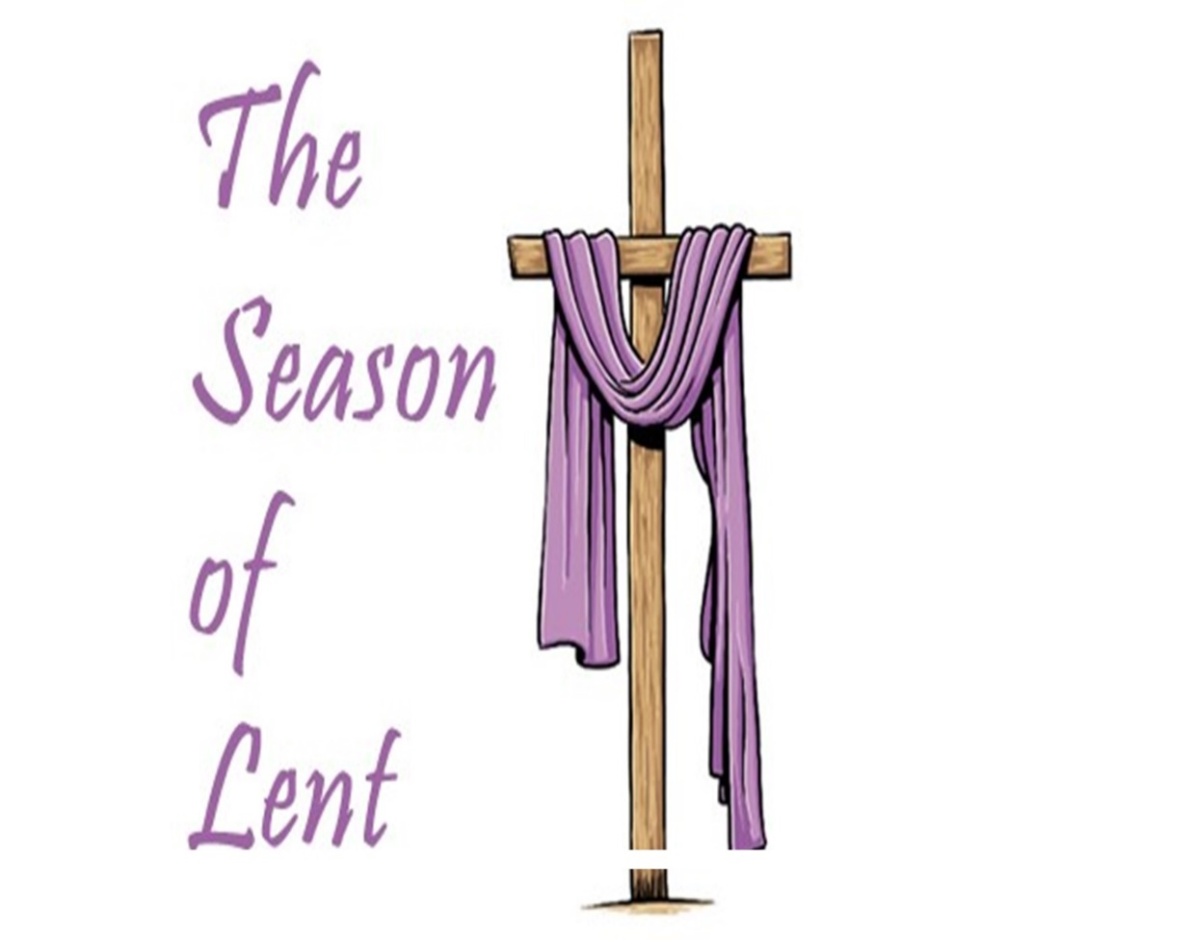

You can contact the pastor at:

Church- 822-8099, e-mail – jimmy.bassham@umcna.org. Call/ Text 612-0403
Frances Gable - Business Manager, finance@hooverfirstumc.org Call/Text (205) 706-8106
Tammi Powell – Music Director, magiccitymusicstudio@yahoo
Order of Worship

Gathering Music Connie Logan, Organ Joyce Godwin, Harpist
Welcome and Announcements

The Prelude ”Alas! And Did My Savior Bleed” HooverFirst
Music Trio

Choral Call to Worship ”Spirit Song” J. Wimber

*Hymn of Praise “Ask Ye What Great Thing I Know” No. 163

*Collect “For Holiness of Heart”

Lord, I want to be more holy in my heart. Here is the citadel of all my desiring, where my hopes are born and all the deep resolutions of my spirit take wings. In this center, my fears are nourished, and all my hates are nurtured, and all the deep hungers of my spirit are honored without quivering and without shock. In my heart, above all else, let love and integrity envelop me until my love is perfected and the last vestige of my desiring is no longer in conflict with your spirit.
Lord, I want to be more holy in my heart. Amen

*The Gloria Patri

Glory be to the Father and to the Son and to the Holy Ghost, as it was
In the beginning, is now and ever shall be, world without end. Amen. Amen.

Hymn “O How I Love Jesus” No. 170

Sharing our Joys & Concerns

Choral Call to Prayer “God So Love the World” Beethoven
Arr. D. McIntyre
Silent Meditation and Prayer

The Pastoral Prayer

The Lord’s Prayer
Our Father, who art in heaven, hallowed be thy name, Thy kingdom
come, thy will be done on earth as it is in heaven. Give us this day
our daily bread. And forgive us our trespasses, as we forgive those
who trespass against us. And lead us not into temptation but
deliver us from evil. For thine is the kingdom, and the power, and
the glory, forever. Amen

*Offering Announcement

We are not passing offering plates this morning. There is an offering plate at the back door you can place your offering in when you leave the sanctuary. During this time, you are encouraged and invited to give to keep commitments current. We have several ways you can do this. Mail a check to the church or give online.

Anthem “You Alone Are Holy ” Anon.
The Chancel Choir Tammi Powell, Director

The Scripture Lesson Phillipians 3: 4b –14

4b If anyone else has reason to be confident in the flesh, I have more:
5 circumcised on the eighth day, a member of the people of Israel, of the
tribe of Benjamin, a Hebrew born of Hebrews; as to the law, a Pharisee; 6
as to zeal, a persecutor of the church; as to righteousness under the law,
blameless. 7 Yet whatever gains I had, these I have come to regard as loss because of Christ. 8 More than that, I regard everything as loss because of the surpassing value of knowing Christ Jesus my Lord. For his sake I have suffered the loss of all things, and I regard them a rubbish, in order that I may gain Christ 9 and be found in him, not having a righteousness of my own that comes from the law, but one that comes through faith in Christ, the righteousness from God based on faith. 10 I want to know Christ and the power of his resurrection and the sharing of his sufferings by becoming like him in his death, 11 if somehow I may attain the resurrection from the dead. 12 Not that I have already obtained this or have already reached the goal; but I press on to make it my own, because Christ Jesus has made me his own. 13 Beloved, I do not consider that I have made it my own; but this one thing I do: forgetting what lies behind and straining forward to what lies ahead, 14 I press on toward the goal for the prize of the heavenly call of God in Christ Jesus.

Sermon “That One Thing Jimmy Bassham

*Hymn of Dedication ”Am I a Soldier of the Cross” No. 511

*Benediction

*Choral Response “We Sing of Your Glory” arr. C. R. Young

*The Postlude

Our Prayers

Temmie Bibb, friend of Wilson & Eleanor Talmadge Ruth Nolen
Robin Alyson, sister-in-law of Laurel Hoag Pat and Tom Temple
Len Rhodes, daughter of Nell Howell Reese Wilson, friend of Barbara Assell
Jay and Lynn Howell, son and daughter-in-law Mike Chumley, friend of Jeff Haizlip
of Nell Howell James Herron
Lori Mitchell, friend of Sherri Bassham The Family of Pat Medlin, cousin of Renee
Teresa Woods Norton who passed away on Feb. 19
Carol Collier Tom and Dinah Remington friends of
Nell Howell Barbara Assell

If you, your family, or any friends of family need prayers, please contact our church office at: (205) 822-8099

Income received as of 02/18/2024 $20,485.00

“Stewardship”

Stewardship is most importantly a spiritual practice. Stewardship is our thanksgiving to God for the blessings given to us and our commitment to each other. During this time when some are not worshiping face-to-face, we encourage you to continue to financially support Hoover First United Methodist.

