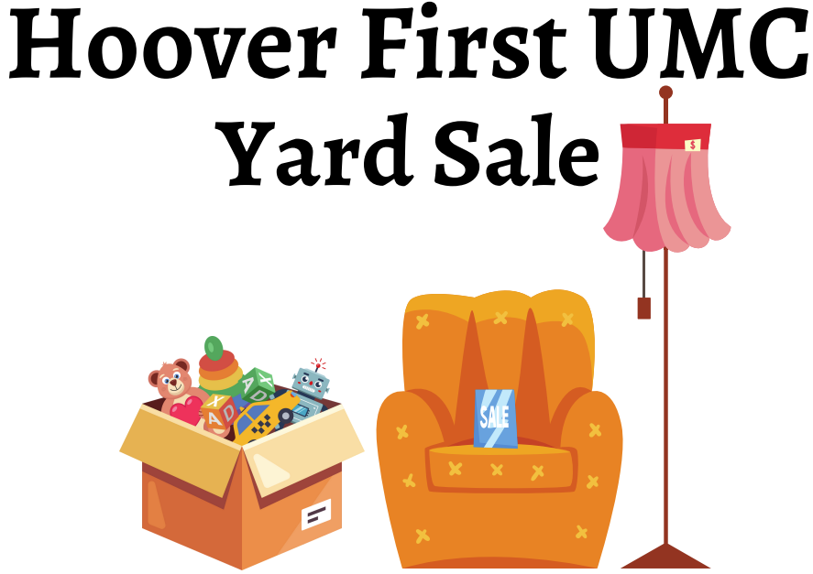

Friday AND Saturday, Oct 6th & 7th
Fri. – 8 am to 3 pm / Sat. – 8 am to 2 pm
1934 Patton Chapel Rd, Hoover AL 35226
“Rain or Shine”
Housewares, furniture, collectibles, jewelry, dishes,
home décor, linens, tools, bicycles,
toys, adult and children’s sports equipment,
large selection of women’s & men’s clothing
(on hangers and by size), books, luggage, lamps, holiday decorations and lots of treasures!
BAKE SALE, too.
Yummy Home Baked Goods and Hot Dogs for sale!

